

|  |
| --- |
| Charles Grinsteadcgrinstead12@gmail.com 1: Excel Homework  Due June 16, 2018 |
|  |

What are three conclusions we can make about Kickstarter campaigns given the provided data?

**FIRST CONCLUSION**

While examining the data, I was asked to calculate the percent funded of each campaign and analyze the number of successful, failed, cancelled, and live campaigns by category and sub-category.

The first thing I noticed about the data is when filtered by category there are a few more successful Kickstarter campaigns than there are failed or cancelled campaigns. When looking at the data one can see that Theater and Music are primarily the campaigns that are successfully funded. Theater accounts for 34% of all campaigns whether successful or failed followed by music 17%. This offers me the conclusion that most users looking to Kickstarter for funding are in the arts genre and less in the food, games, and publishing space. I also found that the majority of the successfully campaigns had a very low campaign goal, whereas campaigns with very ambitious goals were more likely to fail or become cancelled.

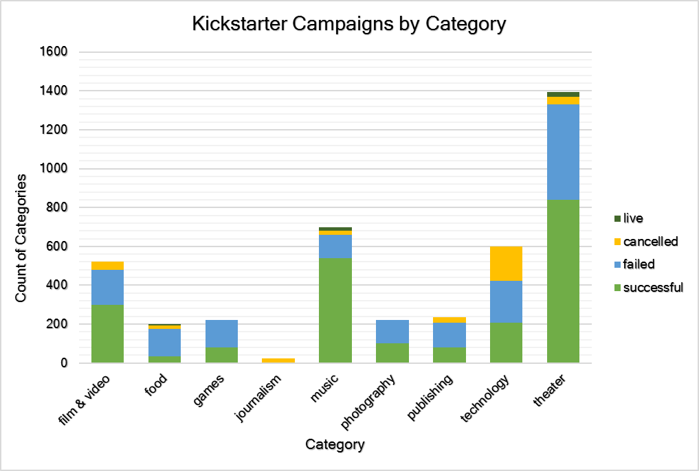

**SECOND CONCLUSION**

Diving deeper into the sub-categories, I uncovered that a surprising number of Plays are being funded through Kickstarter. Plays far exceeds any other sub-category with a total count of 1066 campaigns: 694 successful, 353 failed, 0 cancelled, and 19 live contrasting to an average count per sub-category of about 100 campaigns each. Followed by Plays the next highest sub-category is owned by Rock with a total of 260 campaigns, all of which were successful.

Also, it appears some sub-categories are entirely unsuccessful in using the Kickstarter such as Animation, Gadgets, Food Trucks, Faith, and Translations. It seems that the community that produces Plays has found Kickstarter to be a successful platform with an average goal of $6124.37 compared to the average of all campaigns at $71,938.86.

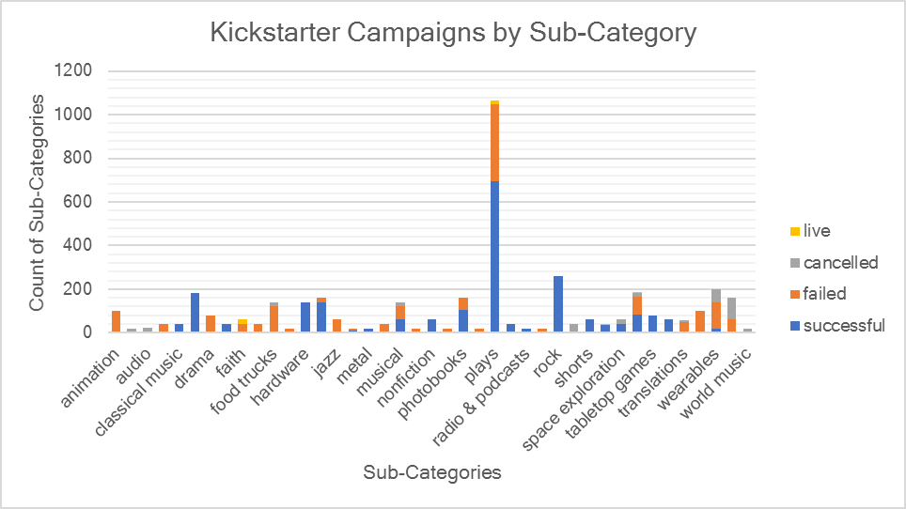

**THIRD CONCLUSION**

Finally, looking at the state of campaigns on a month to month basis, campaigns have a better chance of succeeding towards the early to middle parts of the year and then slowly trend downward. Most pronounced is the peak of successful campaigns at 234 in May and then slowly tapering off each month until hitting the low of 111 in December. The month of January picks up to 182, a difference of 71 campaigns. This is also seen by looking at the inverse trend of successful and failed campaigns over the course of the year, with failed trending slightly upwards.

The number of cancelled campaigns remains consistent throughout the year and accounts for the lowest status of campaigns. It’s not clear why some campaigns are cancelled, but one could assume they were going to fail, as about 98% of these campaigns were under their target goal.

**LIMITATIONS**

Some of the limitations of the data are that it does not consider how Kickstarter advertises their platform. Results could be skewed if the platform fails to successfully market their product and reach audiences to particular categories/sub-categories. Also, Kickstarter has a way to influence which campaigns are successful by labeling a campaign as a “staff-pick” or “spotlight”. While it is not explained what this means, one could assume these campaigns are more heavily advertised to increase the likelihood that they are successful. This is to Kickstarter’s benefit because it receives a commission from successful campaigns and not failed or cancelled ones.

Another limitation of just looking at the success or failed state of a campaign is if a user set their goal too high. A campaign that sets their goal too high relative to the scope of the project or other campaigns in a similar category may have a higher chance of failing.

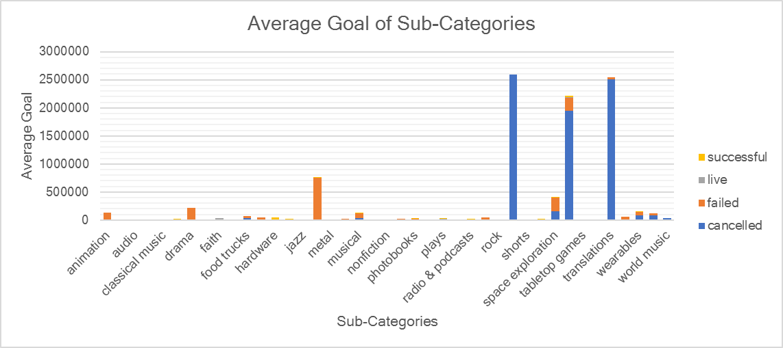

As we can see from the chart above, several campaign sub-categories have a relatively higher average goal than their peers. For example, 40 Science Fiction campaigns have an average goal of $2,591,988.98 and 57 Translation campaigns have an average goal of $2,512,770.00. It is important to note that these campaigns with abnormal goals were either cancelled or failed and is an indicator that some users have unrealistic expectations from the Kickstarter platform.

**OTHER CHARTS/GRAPHS**

As I stated in my first conclusion, it would be helpful to visualize the average and total pledges of each sub-category. This provides perspective to the limitations of the platform in garnering investment dollars to certain sub-categories and highlights any outliers that performed well passed expectations. After observing the summation of pledges by sub-category, one can discern that hardware is worth investigating.

The campaign “3Doodler: The World's First 3D Printing Pen” was able to gather $2,344,134.67 in pledges despite its $30,000.00 goal. This was the case with a few other campaigns exceeding their pledge averages by large margins. One of the issues with the hardware category is that there are not any cancelled or failed campaigns, which would indicate that these are atypical to the campaigns in other sub-categories.

